

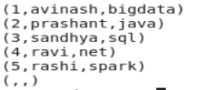

1.concat:



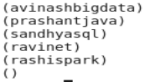

2.



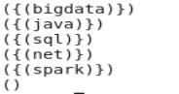

3.



4.

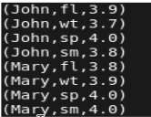





5.





6.





7.'



8.



9.flatten()

Flatten un-nests tuples as well as bags.  
consider a relation that has a tuple of the form (a, (b, c)). The expression GENERATE $0, flatten($1), will cause that tuple to become (a, b, c).

10.isempty()

Checks if a bag or map is empty.